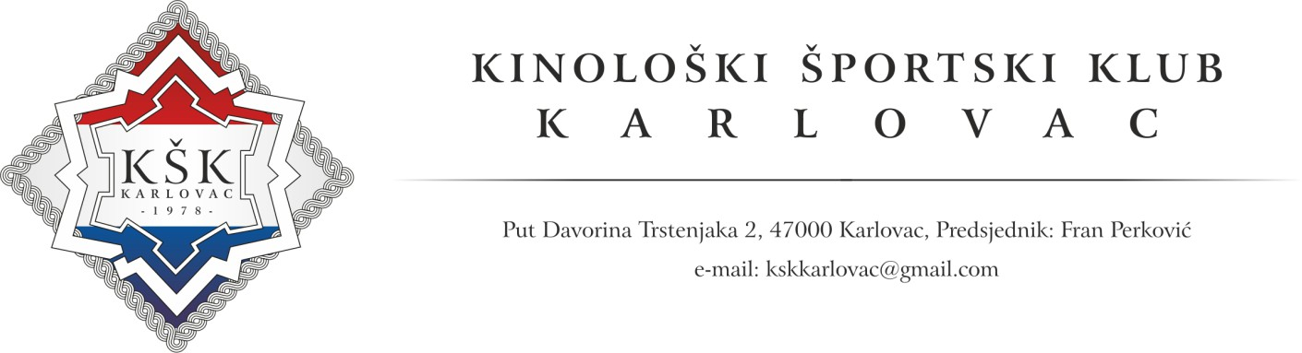

Dear exhibitors,

We would like to thank you for attending 4 Rivers Winner 2024 shows in Karlovac. As organizer of the shows, we would like to make you stay as comfortable as possible.

For all exhibitors that have decided to come to our show with campers, we have secured a special place right on showground. Also, we are going to provide electricity (please prepare standard plugs type F for connection).

We are kindly asking you to fill out a form and send it back to us, so we could easily plan a camping space:

**Arrival planning (possible on Wednesday - 9th of October 2024 after 5 PM)**

**Departure planning (latest on Monday – 14th of October 2024 until 10 AM)**

**Vehicle registration number**

**Signature**

**Sending this document, you agree with above terms and conditions as well as a price of 40 € per day. Payment will be possible to make on show office on first day of the show.** We are looking forward to your arrival!

Best regards,

Kinology Sport Club Karlovac